

# Oxford Eye Hospital Minor Ops Referral Form

Please see accompanying referral guidelines to aid referral

## Patient’s Details

Given name:

Surname:

Date of birth:

NHS Number:

Address and post code:

Hospital number:

Email address:

Mobile / home telephone number:

## Reason for referral (please tick)

Suspect periocular tumour (BCC / SSC / Melanoma / Sebcaceous / other) [ ]

Benign periocular lesion causing significant visual impact or pain [ ]

Chalazion non-resolving with conservative measures >3 months [ ]

Trichiasis suitable for electrolysis (few trichitic lashes; <10) [ ]

Periocular lesion – unclear type / other [ ]

## History and clinical photo

Please attach photo where possible, and brief description of lesion / history (appearance, duration, size, change over time, symptoms etc.)

## Oxford Eye Hospital Minor Ops Referral Guidelines.

Welcome to OEH Minor ops. This scope of this service includes:

* Management of periocular skin lesions that are suspicious for malignancy
* Chalazions present more than four months and amenable to surgical drainage
* Minor/benign lesions subject to criteria outlined below in section 3
* Symptomatic trichiasis

### 1) Periocular lesions concerning for malignancy

*Where possible, please include photos in the referral.*

Where the lump is rapidly growing, abnormally located and / or is displaying features suspicious of malignancy, specialist assessment should be sought using the 2 week wait pathway. Patients should be told to expect biopsy of the lesion in minor ops, followed by onward referral for appropriate management depending on the results.

The most common types of skin cancers are **basal cell carcinoma** (BCC), followed less commonly by **squamous cell carcinoma**, **sebaceous gland carcinoma** and **malignant melanoma**.

#### Basal cell carcinoma

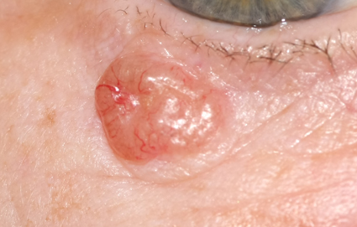

#### Squamous cell carcinoma

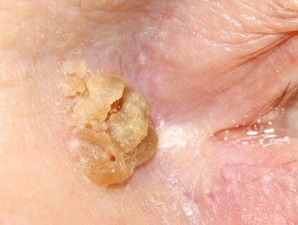

#### Sebaceous cell carcinoma

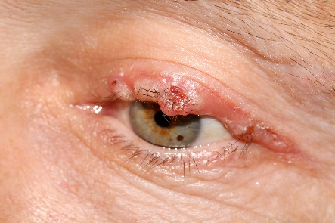

### 2) Meibomian cysts and hordeola

*Where possible, please include photos in the referral.*

**Meibomian cysts** (**chalazia**) arise from obstructed oil glands of the tarsal plate. The majority resolve with regular hot compresses and eyelid hygiene +/- courses of topical antibiotics.

Sizable chalazia present for at least four months which would be amenable to surgical drainage can be considered for referral to MOPS. It is common for a small residual firm lump to persist for several months following chalazion – these are typically painless and not suitable for surgical drainage.

A **Stye** (hordeolum) is an acute, painful inflammation of a sebaceous gland (meibomian or Zeiss) in the eyelid, usually contributed by normal bacteria on the lid skin. They typically resolve with hot compresses and do not require surgery. If an associated cellulitis develops, oral antibiotics should be prescribed.

#### Upper lid chalazion

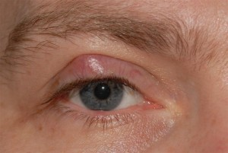

#### Acute hordeolum

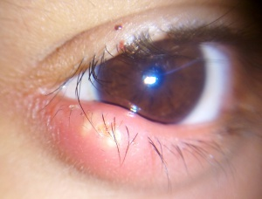

### 3) Minor periocular skin lesions

*Where possible, please include photos in the referral.*

Minor eyelid lesions include **eyelid papillomas** or skin tags, **cysts of moll**, **cysts of zeis**, **xanthelasma**, **seborrheic keratoses**, **sebaceous cysts** and **epidermoid cysts**.

Policy: surgery or treatment for minor eyelid lesions will only be funded in accordance with criteria below:

* There is well documented evidence of significant pain **OR**
* Recurrent infection **OR**
* Recurrent bleeding **OR**
* There is significant impact on vision affecting functionality

#### Sebaceous cyst

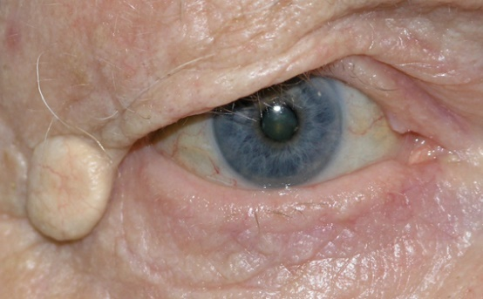

#### Papilloma (skin tag)

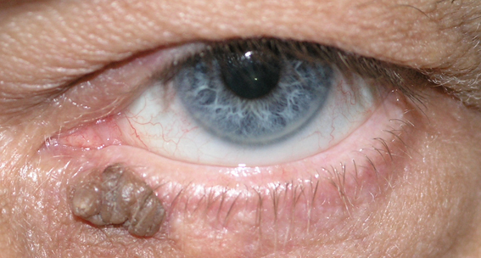

#### Cyst of moll

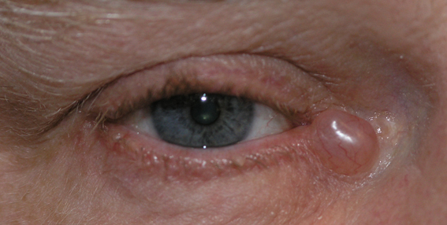

#### Cyst of zeis

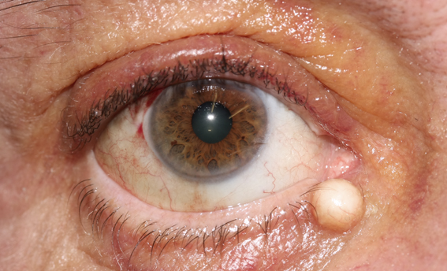

### Trichiasis

Patients with misdirected eye lashes affecting the ocular surface should be referred for treatment.

***Please document eyelid position (e.g. if there is entropion), corneal appearance, extent of trichiasis and symptoms in the referral.***

Treatment options available in Minor Ops include **electrolysis** (suitable only if very few trichitic lashes) and **cryotherapy**. Cases requiring surgery for malpositioned eyelids will be directed to a clinic to discuss options rather than Minor Ops.